**1) Why testing is required?**

A: Testing is required to ensure the performance of software application or product without any defects/bugs before the production.

**2) What types of application we test?**

A: web applications

    desktop/windows applications

    Mobile applications

    Web services (SOAP/REST)

    ETL jobs, database validations

    Back end/batch programs/windows services

**3) what is SDLC and different phases in SDLC?**

A: Software development life cycle (SDLC) is a process to develop the application

Phases are:

a) Requirement Analysis and planning: The senior team members analyzes the requirements given by the clients/users. They will check whether the requirement is feasible or not (can be done or not). They also identify the risks associated with project. This high level requirement will be written in BRD (Business Requirement document) by Business Analyst.

b) Define/Design: In this stage Business Analyst define more details about requirements (which are in BRD) in the form of SRS (software requirement specification) or Use Case diagram.

As part of design,

Senior Developers write High Level Design Document (HLD)

Developers write Low Level Design Document (LLD)

Senior Testers write Test Planning document

c) Implementation/Development: Developers write the code for the requirements. Testers write test cases as per SRS

d) Testing: Execute the test cases what we prepared in previous stage

e) Deployment: Release the tested code to production

f) Maintenance: Support team monitoring the system that is running in production

**4) what is waterfall method in SDLC?**

A: It is a sequential (or step by step) process.This means that as each of the eight stages (conception, initiation, analysis, design, construction, testing, implementation, and maintenance) are completed, the developers move on to the next step.

Once a step has been completed, developers can’t go back to a previous step (not without scratching the whole project and starting from the beginning). There’s no room for change or error, so a project outcome and an extensive plan must be set in the beginning and then followed carefully.

**5) what is the process in agile model?**

A: Agile methodology follows an incremental approach. Developers start off with a simplistic project design, and then begin to work on small modules. The work on these modules is done in weekly or monthly sprints, and at the end of each sprint, project priorities are evaluated and tests are run. These sprints allow for bugs to be discovered, and customer feedback to be incorporated into the design before the next sprint is run.

**6) what is scrum methodology?**

A: Scrum is a subset of Agile.  Scrum is most often used to manage complex software and product development, using iterative and incremental practices. Scrum processes enable organizations to adjust smoothly to rapidly-changing requirements, and produce a product that meets evolving business goals

**7) what is daily standup meeting and what we discuss?**

A: A daily stand-up meeting is a short organizational meeting that is held each day. The meeting, generally limited to between five and fifteen minutes long, is sometimes referred to as a stand-up, a morning roll-call or a daily scrum.

We discuss about the work we did the before day, the work we do today and about the project.

**8) what is user story/feature/sprint back log items and tasks in user story?**

A: The user story describes the type of user, what they want and why. A user story helps to create a simplified description of a requirement.

Features are the changes that add new functionality or modify existing functionality.

The sprint backlog is a list of tasks identified by the Scrum team to be completed during the Scrum sprint.

A task is a piece of work that needs doing, usually in order to build toward a bigger user story.

**9) what is sprint planning and spring retro?**

A: The sprint planning meeting is attended by the product owner, Scrum Master and the entire Scrum team. During the sprint planning meeting, the product owner describes the highest priority features to the team. The team asks enough questions that they can turn a high-level user story of the product backlog into the more detailed tasks of the sprint backlog.

**10) what is burndown chart and velocity?**

A:  The burndown is a chart that shows how quickly a team is burning through the customer’s user stories. It shows the total effort against the amount of work we deliver each iteration.

The rate of progress of a Scrum Team is called velocity.

**11) what is product backlog item and sprint backlog items?**

A: Product Backlog Items can range from specifications and requirements, to use cases, epics, [user stories](https://www.scruminc.com/independent-user-stories/), or even bugs and chores. Each PBI must have these qualities: Description, [Business Value](https://www.scruminc.com/calculating-business-value/), Estimate, Order.

The sprint backlog is a list of tasks identified by the Scrum team to be completed during the scrum sprint

**12) what is user acceptance criteria test cases?**

A: User acceptance testing (UAT) is often considered the last phase in the web development process, the one before final installation of the software. UAT is usage of the software by people from the intended audience and recording and correcting of any defects which are discovered.

**13) what is v model?**

A: V - Model is an extension of the waterfall model. For every single phase in the development cycle there is a directly associated testing phase. This is a highly disciplined model and next phase starts only after completion of the previous phase. Below is the figure that depicts the v model.

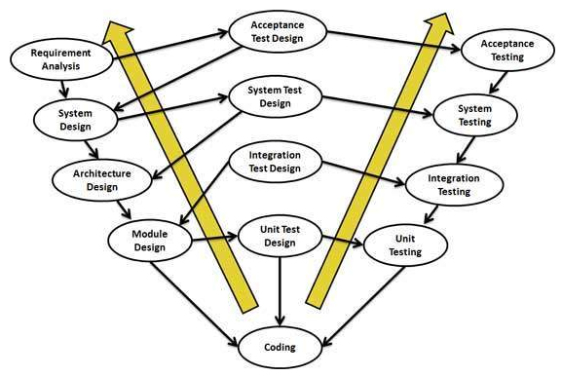

**14) what is STLC?**

A: Software Testing Life Cycle (STLC) is the testing process which is executed in systematic and planned manner. In STLC process, different activities are carried out to improve the quality of the product. Let’s quickly see what all stages are involved in typical Software Testing Life Cycle (STLC).

Following steps are involved in Software Testing Life Cycle (STLC). Each step has its own Entry Criteria and deliverable.

Requirement Analysis

Test Planning

Test Case Development

Environment Setup

Test Execution

Test Cycle Closure

**15) what is defect?**

A: When actual result deviates from the expected result while testing a software application or product then it results into a defect.

**16) how to arise a defect and what we specify while logging defect?**

A: When a tester finds a bug or defect, it’s required to convey the same to the developers. Thus they report the bugs with the detail steps and are called as Bug Reports, issue report, problem report, etc. This Defect report or Bug report consists of the following information: Defect ID, Defect Description, Product Version, Detail Steps, Date Raised, Reported By, Status Fixed by, Date Closed, Severity, Priority.

**17) what is defect lifecycle?**

A: Defect life cycle, also known as Bug Life cycle is the journey of a defect cycle, which a defect goes through during its lifetime. It varies from organization to organization and also from project to project as it is governed by the software testing process and also depends upon the tools used.

The below figure tells about the workflow of the defect life cycle.

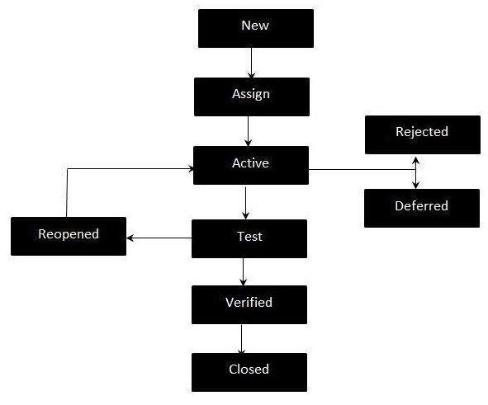

**Different types of testing:**

**18) What is unit testing?**

A: Unit testing is testing the smallest testable parts of an [application](http://searchsoftwarequality.techtarget.com/definition/application), called units. Unit testing is often automated but it can also be done manually. The purpose is to validate that each unit of the software application as designed. Usually, Developers perform the Unit testing as this type comes under white box testing. Unit testing is the first level of the testing (which is before integration testing)

**19) when do we do regression testing?**

A: Regression testing is initiated when programmer fix any bug or add new code for new functionality to the application or system. It is performed pretty frequently to ensure the functionality and quality of the application or system.

**20) What is integration testing?**

A: **Integration Testing**is a [level of software testing](http://softwaretestingfundamentals.com/software-testing-levels/) where individual units are combined and tested as a group. Developers or testers can perform this testing.

**21) when do we use integration testing?**

A: Integration Testing is performed after [Unit Testing](http://softwaretestingfundamentals.com/unit-testing/) and before [System Testing](http://softwaretestingfundamentals.com/system-testing/).

**22) when do we use smoke testing and sanity testing?**

A: Smoke Testing is done whenever the new functionalities of software are developed and integrated with existing build that is deployed in QA/staging environment. It ensures that all critical functionalities are working correctly or not. Smoke testing is done after the build is released to QA. With the help of smoke testing, most of the defects are identified at initial stages of software development.

**23) what is UAT?**

A: Testing with respect to user needs, requirements, and business processes conducted to determine whether or not a system satisfies the acceptance criteria and to enable the user, customers or other authorized entity to determine whether or not to accept the system is UAT. It is performed after system testing and before the actual user uses the application or system.

**24) what is alpha and beta testing?**

A: Alpha testing is a type of acceptance testing which is performed to identify all possible issues/bugs before releasing the product to everyday users or public. The focus of this testing is to simulate real users by using black box and white box techniques

Beta Testing of a product is performed by "real users" of the software application in a "real environment" and can be considered as a form of external user acceptance testing. It is the final test before the production. Direct feedback from customers is a major advantage of Beta Testing which helps to tests the product in real time environment.

**25) when do we use white box testing and block box testing?**

A: White Box Testing is a software testing method which require knowledge of the internal code which is usually performed by the developers.

Black Box Testing is a software testing method which does not require any knowledge of the internal code which is usually performed by the testers.

**26) what we will do if come across any critical severity issue before release day?**

A: 1) Explain the situation to client and ask some more time to fix the bug.

2) If the client is not ready to give some time then analyze the impact of defect/bug and try to find workarounds for the defect and mention these issues in the release notes as known issues or known limitations or known bugs.

3) Normally this known issues or known limitations (defects) will be fixed in next version or next release of the software.

**27) when do we use automation testing?**

A:Inproject lifecycle, usually because of with tight deadlines, or just not being aware enough, we either tend to overlook or fail to identify automation of the manual and repeated tasks. You reduce the time you spend on repetitive tasks, speed up things and learn alongside!

**28) what tester will do in each phase of SDLC?**

A: 1. Requirement Analysis stage - PM, Tech Lead, Test lead will review the document

2. Design Stage - PM or Test lead will review the document

3. Implementation Stage – Test lead or testers will prepare Test plan and test cases

4. Testing Stage - Tester will execute the test case

**29) What is the difference between load testing and performance testing?**

A: Load test: It is the test that involves to put a determined load on an application to verify how it behaves

Performance test: It is a load test limited by the load defined by the specification of the application. This test is to verify or confirm that the application will work at the planned performance.

**30) what are the different types of non-functional testing?**

A: Load/Performance testing Compliance testing

Compatibility testing Usability testing

Localization testing Security testing

Reliability testing Stress testing

**31) what is test case?**

A: A test case is a set of conditions or variables under which a tester will determine whether a system under test satisfies requirements or works correctly. A test case template consists of Test Suit ID, Test Case ID, Test Case summary, Requirement, Test Procedure, Test data, etc.

**32) what is test planning/test strategy document?**

A: Test planis a document describing the scope, approach, resources and schedule of intended test activities. This document contains different section liketypes of testing, exit and entry criteria, etc.

Test strategy is a set of guidelines that explains test design and determines how testing needs to be done.

**33) what is TDD and BDD (cucumber framework)?**

A: In software engineering, Behavior-driven development combines the general techniques and principles of TDD with ideas from domain-driven design and object-oriented analysis and design to provide software development and management teams with shared tools and a shared process to collaborate on software development.

Test-driven development (TDD) is a software development process that relies on the repetition of a very short development cycle: first the developer writes an (initially failing) automated test case that defines a desired improvement or new function, then produces the minimum amount of code to pass that test, and finally refactors the new code to acceptable standards

**34) what is priority and severity in defect?**

A: Defect priority is said as in like which needs to be addressed first compared to other defects and measured as high or low.

Defect severity is based on the impact that defect leaves on the development or the function of the application or system. It is measured as critical or non-critical

**35) how to estimate test cases?**

A: There are 3 estimation techniques:

1. Work Breakdown Structure (WBS): breaking down the project into small pieces
2. Three Point Estimation: based on statistical data
3. Functional Point method: Measure the size and give weightage to each function point

**36) what is most challenge defect u came across?**

A: There was a web app which had a field that had maximum character limit of 13 characters, I entered 12 characters(alphabets) and 13th character as an emoji. Since emoji takes 2 characters, the app crashed.

**37) how to deal the production defects?**

A: Normally end user will report this issue.

We need to talk to them (end users) and reproduce the issue with in staging environment

Create defect in defect tool under the production release version

Developers will fix the issue

We (QA) test the issue on production version code (staging) and release the fix to production after we verify

We have to create a defect on current sprint/release so that developer will add this code to the current sprint/release

**38) what are test design techniques?**

A: There are 2 types of techniques.

1. Static test design technique: Static testing refers to the testing of software manually or with the help of tools. Usually carried out during the early phase of software development life cycle. This technique is further divided into:
2. Manual
3. With the help of tools
4. Dynamic test design technique: Dynamic testing involves execution of the test object (application) on a computer. Carried out during the validation process. It is further divided into:
5. Specification-based
6. Structure-based
7. Experience-based

**39) what will we do if we don’t have time to test call test cases?**

A: We have to take care at the start of the testing process to ensure that the testing is done accurately before the production. We have to take care of few factors like accurate estimation of the project and time, test management tool. The best way is to take help from the colleagues for the work to be done on time.

**40) how can we learn the functionality of system?**

A: The functionality of a system or an application can be known from business requirement document or from Software requirement specifications or from the Business Analyst or Developers.

**41) what are the tools used to manage defects/stories?**

A: Popular bug tracking tools are:

Bugzilla

HP ALM/ Quality Center

JIRA

Mantis Bug tracking tool

IBM Rational Clear Quest

Light House

**42) who will assign the work?**

A: Team Lead/ Architect

**43)what are the types of test metrics we use normally?**

A: In software testing, Metric is a quantitative measure of the degree to which a system, system component, or process possesses a given attribute.

Types:

Process Metrics: It can be used to improve the process efficiency of the SDLC

Product Metrics: It deals with the quality of the software product.

Project Metrics: It can be used to measure the efficiency of a project team or any tools being used by the team members

**44) what is traceability matrix?**

A: The RTM captures all requirements and their traceability in a single document delivered at the conclusion of the life cycle.

Parameters:

Requirement ID

Risks

Requirement Type

Requirement Description

Trace to Design Specification

Unit Test Cases

Integration Test Cases

System Test Cases

User Acceptance Test Cases

Trace to Test Script

**45) what are typical environments we have in projects?**

A: There are 4 categories:

1. Language-centered
2. Structure-oriented
3. Tool Kit
4. Method Based

**46) what are different defect metrics and measurements we prepare?**

A: There are 2 types of test metrics.

1. Base metrics: Base Metrics are the Metrics which are derived from the data gathered by the Test Analyst during the test case development and execution.
2. Calculated metrics: Calculated Metrics are derived from the data gathered in Base Metrics

**47) What is staging environment?**

A: The staging environment lets you move Web site assets within and across different environments. For example, you can move a new Web page or a marketing campaign from a test environment to a production environment.

The staging environment consists of two components:

* The staging database server.
* The staging server.

**48) what is development environment?**

A: The development environment is the set of processes and programming tools used by the developers to create a program or software product.

**49) what is QA environment?**

A: A QA environment is the environment where the testers test the data, hardware, and software that closely simulate the Production environment.

**50) what is production environment?**

A: Production environment is the environment where the developed product is deployed and tested or used by the end users or customers.